

[plan mode]:
This is a static html project called Bucks2Bar. We need a UI library for styling and we need income and expense inputs for months jan - dec. The UI should be split into 2 tabs ("Data" and "Chart"), the chart tab plots a bar chart of the income and expenses from the inputs in the Data tab. We will need a suitable chart library to render this chart.

[plan mode]:
To asnwer your questions:
1. We don't need data persistence.
2. Yes
3. Bootstrap 5

[plan mode]:
1. Update automatically
2. Yes

[agent mode]:
Start implementation

https://github.com/tomphill/newbucks2bar

Setup
VS code Add an extension

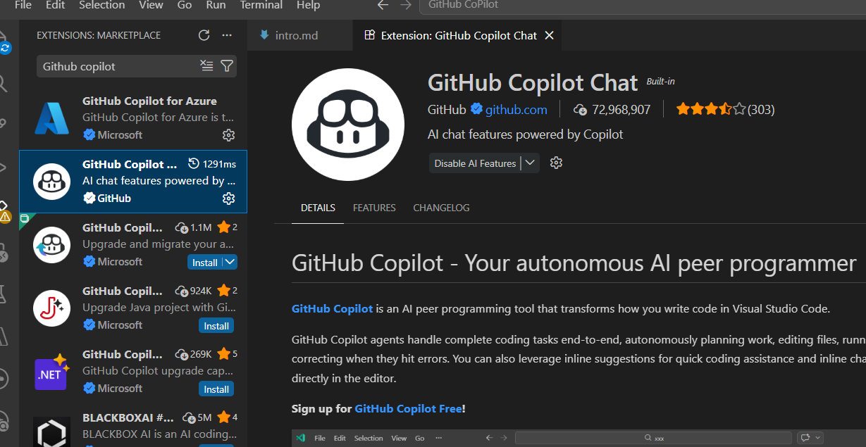

Please read this before you start the course!
The associated GitHub repository for all the code in this course is available here:
Project 1:
https://github.com/tomphill/newbucks2bar
Project 2:
https://github.com/tomphill/linkshortenerproject
https://github.com/tomphill/linkshortenerproject/tree/dashboard
Please double check your package versions against this repository, and compare your code if you get stuck.
You can also post in the Q&A section of the course if you need assistance.
Refer to the last lecture titled 'BONUS' for more courses and additional learning materials such as my YouTube channel where I post weekly tutorials and a dedicated facebook group for all of my courses. Enjoy! :)
✨Also if you haven't already done so I would really appreciate it if you left a rating and / or review of the course on udemy :) This is entirely optional but I would really appreciate it if you left a rating and / or review. It takes 2 seconds to leave a rating and it would mean the world to me if you could do that :) ✨
Resources for this lecture
https://github.com/tomphill/newbucks2bar
https://github.com/tomphill/linkshortenerproject
https://github.com/tomphill/linkshortenerproject/tree/dashboard

GitHub Copilot inline suggestions and next edit suggestions

2 main features
- Auto complete features
- Inline Suggestion
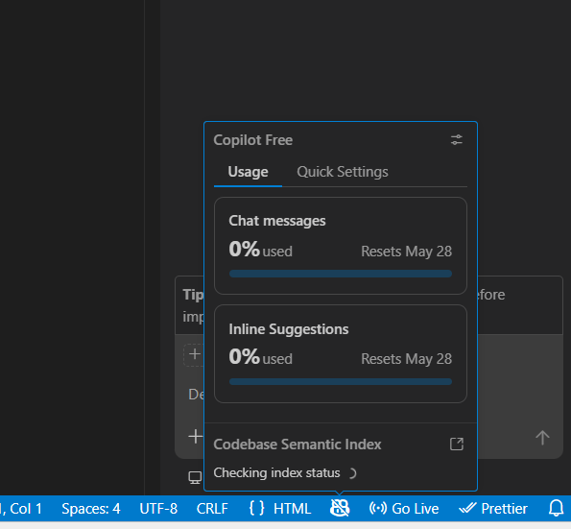

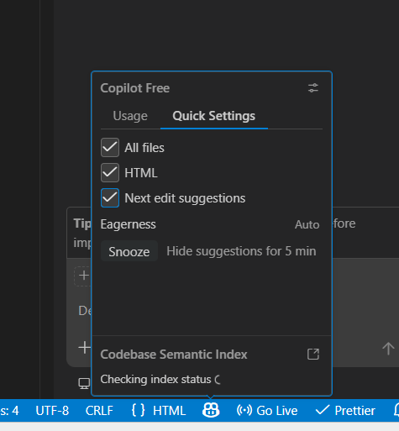

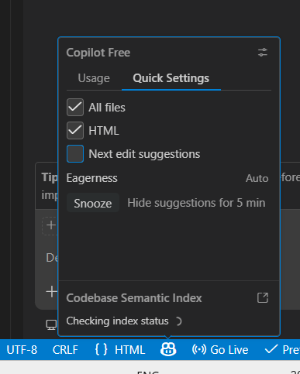

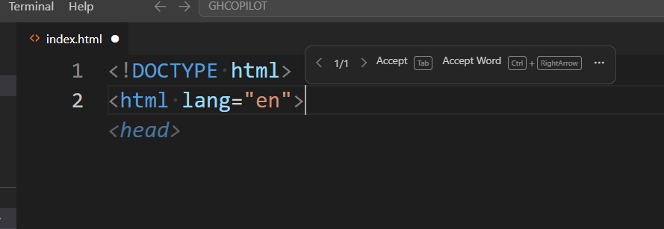

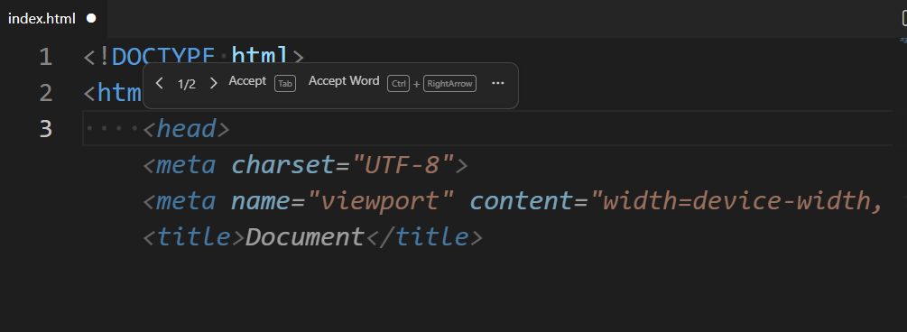
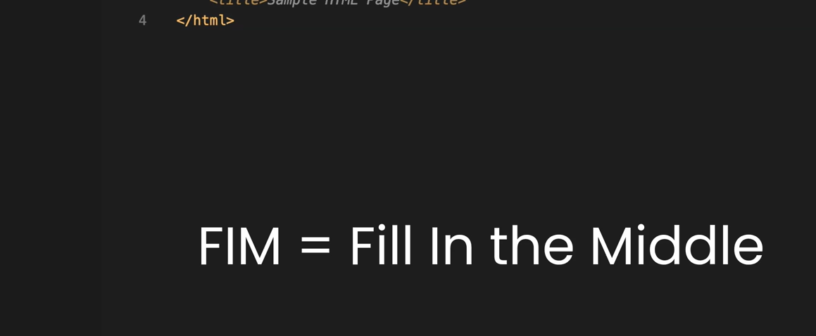
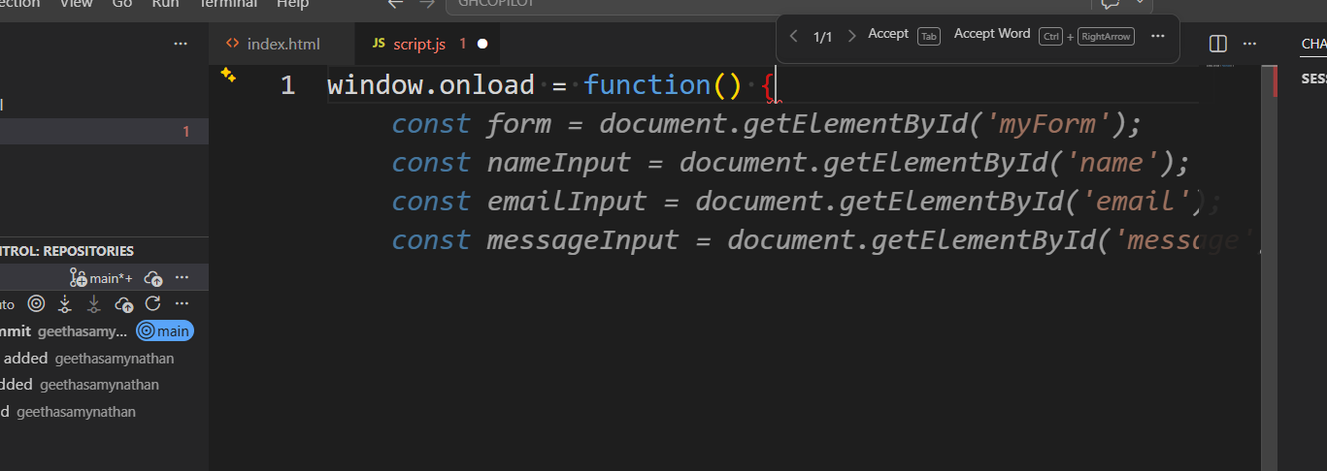

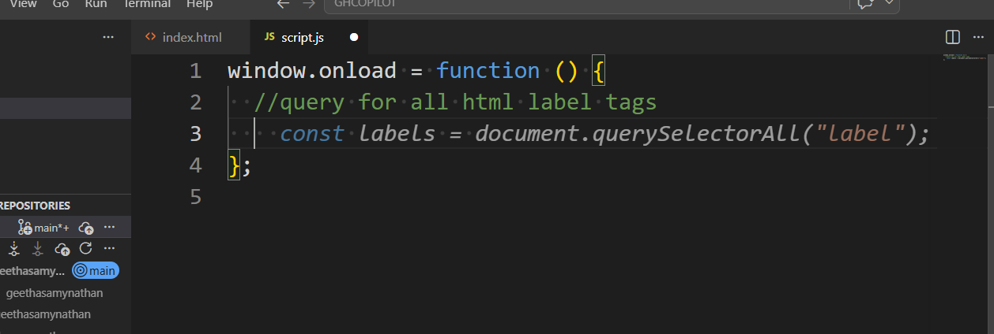

Next edit suggestion

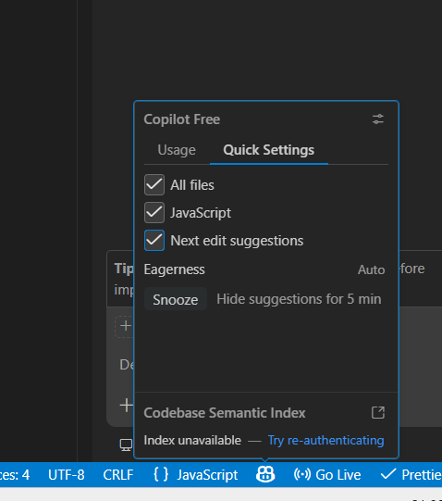

function getAllLabels() {
return document.getElementsByTagName("label");
}

window.onload = function () {
//query for all html label tags
const labels = document.getElement
sByTagName("label");
};

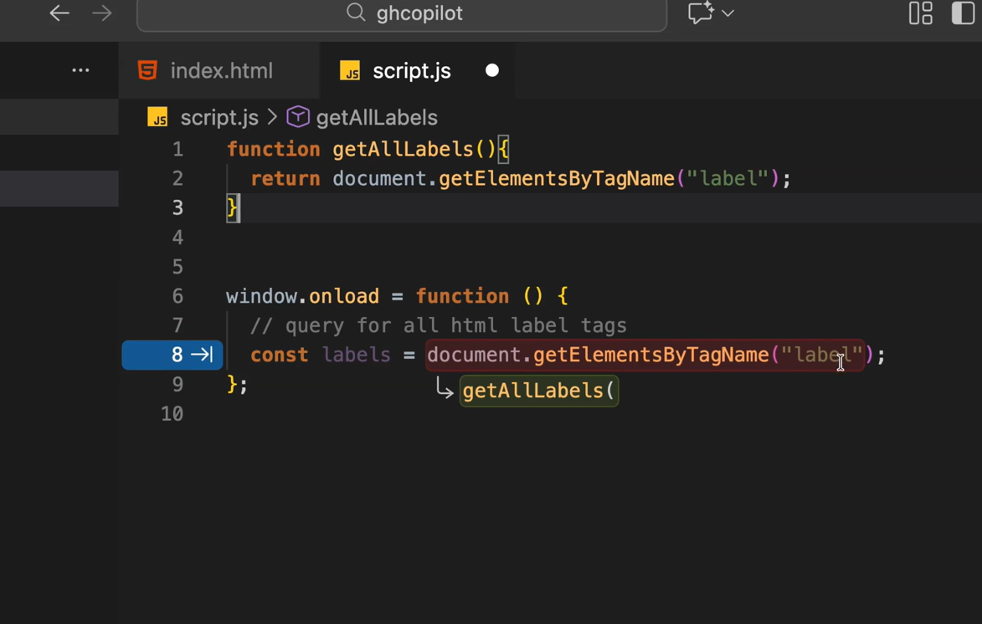

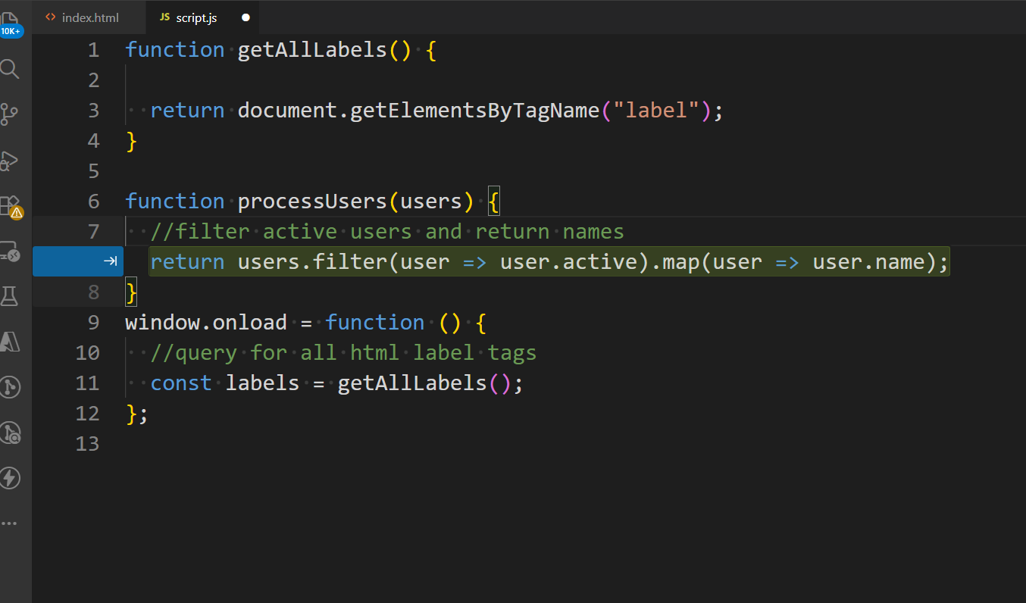

function getAllLabels() {
return document.getElementsByTagName("label");
}

function processUsers(users) {
//filter active users and return names
// fetch data from API and handle errors
}
window.onload = function () {
//query for all html label tags
const labels = getAllLabels();
};

